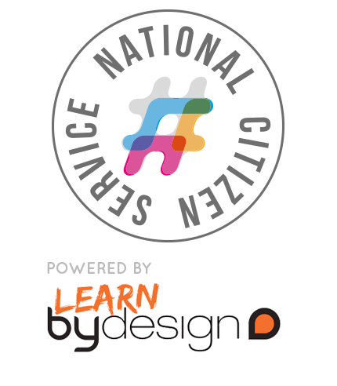
I’d like to share my
NCS experience with you…

My name is Emily and I’ve just finished at Melbourn Village College.

I’m on the Social Action Phase of NCS and today we’ve been cycling to help raise money for our chosen charity in Cambridge. I’ve really enjoyed the people and the positive atmosphere and I love the freedom.

I feel proud that I’ve reached my goal and I’ve learned about myself that I CAN keep going!

You should take part in NCS because it gives you opportunities and you will meet so many people that can inspire you to challenge yourself.
I’d like to share my
NCS experience with you…

My name is Zoe and I’ve just finished at Melbourn Village College.

To help our chosen charity as part of our Social Action Project our team is aiming to travel 6000km to raise money! I’ve loved the positive atmosphere on NCS and today I’ve enjoyed the team work as we went to the gym at 9am, did a fun run at 11am and then went busking at 1pm.

I feel proud because I’ve pushed myself and I’ve learned that I can keep going.

You should take part in NCS because it WILL provide you with lots of opportunities!
I’d like to share my
NCS experience with you…

My name is Ben and I’ve just finished at Melbourn Village College.

This week we’re on our Social Action Phase of NCS and today we’ve been helping to raise money for our chosen charity – Happy Days – by doing a car wash and a cake sale.

What I’ve loved about NCS so far is meeting new people, experiencing new challenges and the locations that we’ve stayed at, like North Wales for our Week 1 Adventure Phase, the University of Bedfordshire for our Week 2 Discovery Phase and Hills Road Sixth Form College and out and about around Cambridgeshire for our Week 3 and 4 Social Action Phase.

I think you should do NCS because it gives you the chance to make friends with those who will be going to the same sixth college as you.

